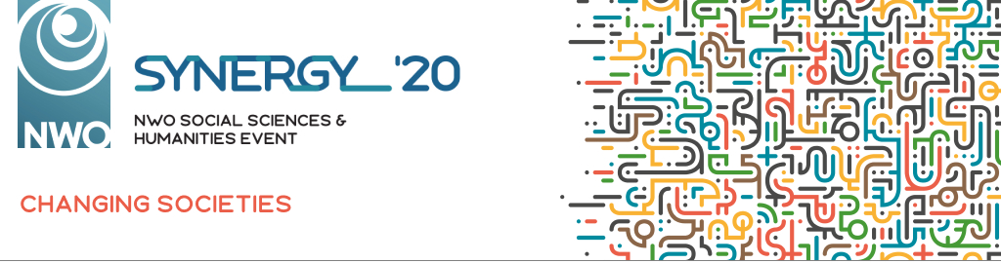

SUBMISSION FOR THE SYNERGY AWARD
We only accept digital documents, not hand written.
Send this form to synergy2020@nwo.nl before 6 December 2019

First name:

Last name:

University:

Faculty and Department or Research Institute:

SSH discipline:
Linguistics, Historical sciences, Philosophy and religion studies, Cultural sciences, Economics and business administration, Behaviour and education, Law and public administration

E-mail address:

Phone number:

When do you expect to finish your PhD research? (or what was the date of your defence?)

Your idea - Describe the focus of your PhD research, your idea for impact, which societal challenge your idea relates to and how it stems from your research (max 800 words)

Additional remarks, something we should know?

