How to set up an assignment in canvas.
In the left menu of your course, click on Assignments.

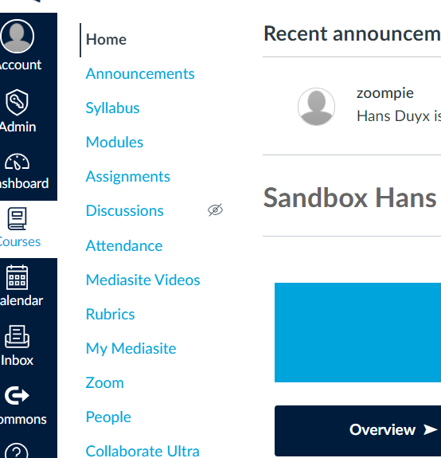

Click on + Assignment to create a new assignment.
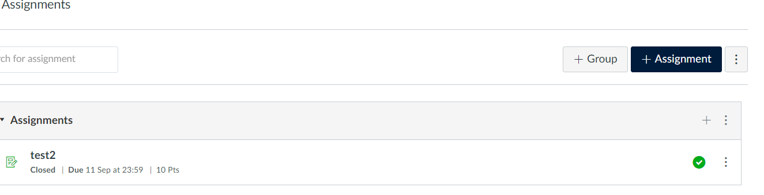

Enter the name of your assignment, deadline and –if applicable- instructions.
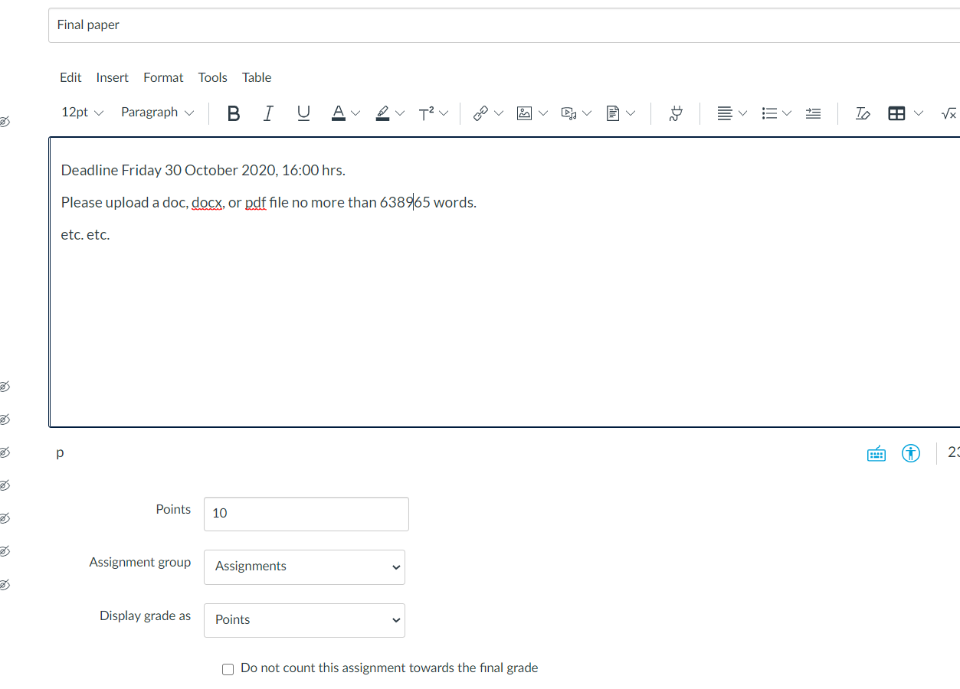
Enter the number of points for this assignment and choose how canvas will display the grade (drop-down list). Check this box if canvas should not count this assignment to the final grade in your course.

Select your submission type (online, file upload will be most common)
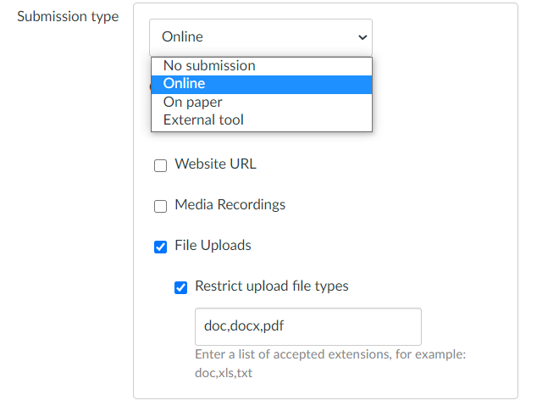
Check this box –if applicable- and enter accepted extensions, for instance to avoid uploads like .pages.

By default, unlimited attempts are allowed. Switch to Limited and select the number of attempts if you want to change this option.
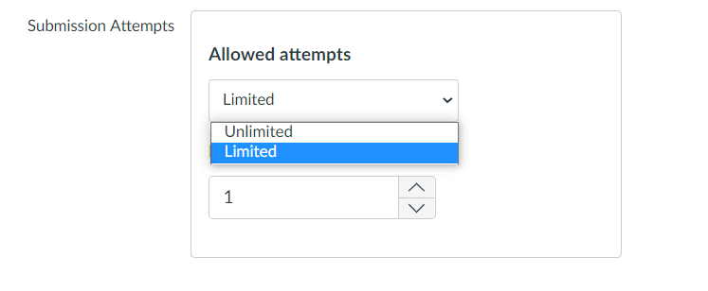

If the upload should be checked against plagiarism, choose URKUND to activate the plagiarism check, leave the other options unchecked.
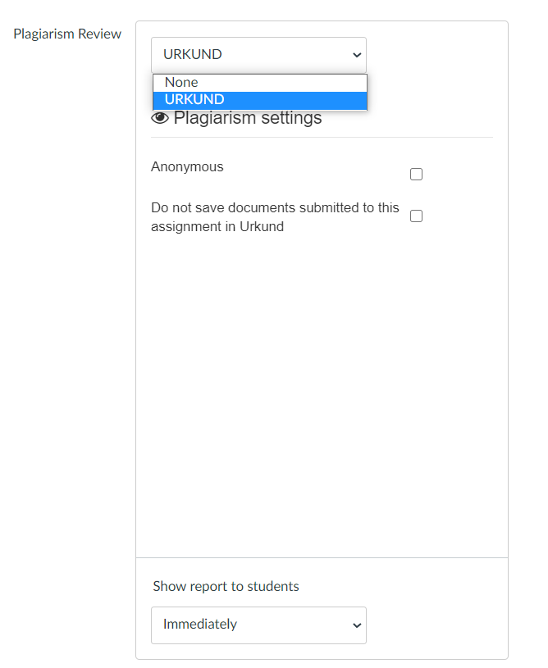
From the drop-down list, you can change the default option Show report to students Immediately.
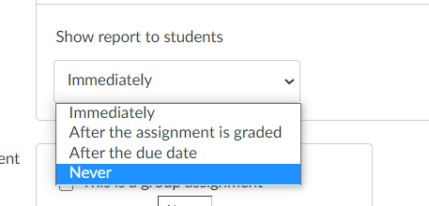

Leave the next two boxes unchecked in case of an individual assignment without peer reviews.
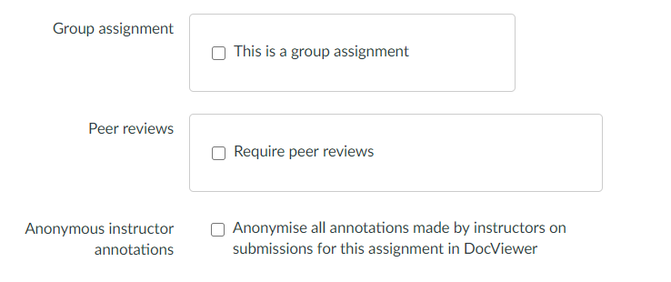
Check this box if you want your annotations to be anonymous.

Assign the assignment to all the students (Everyone), or select one or more tutorial groups (Sections) by clicking in this field.

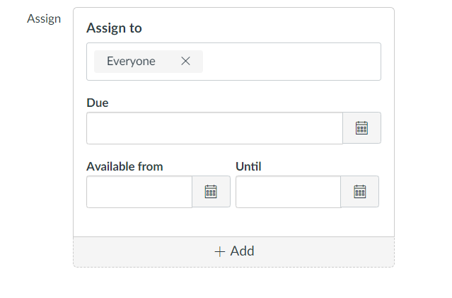
Enter a Due date/time and a Until date/time (both entries should be the same). Keep the date and time within office hours (in case of issues support will be available). Enter an Available from date/time if the assignment should not be available to students immediately.

You can add an extra assign to option, and –for instance- create different due dates for different sections for the same assignment.

Do not forget to save and publish your assignment.

