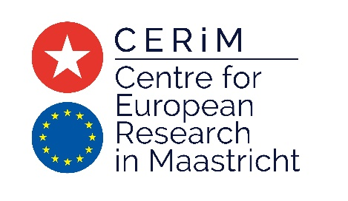

“Debating the EU’s Future:
Do we need institutional reforms? Will we get them?”

Roundtable Debate at Maastricht University
C-1.03 (Colloquium room 1)
Tongersestraat 53 - Maastricht
8 December 2017

10:15 – 10:45 Registration and Coffee

10:45 – 11:00 Welcome and Introduction

11:00 – 12:45 Roundtable Debate

Panelists
- Deirdre Curtin, Professor of EU Law, European University Institute
- Michelle Everson, Professor of EU Law, Birkbeck College, University of London
- Graham Smith, Member of Cabinet of the European Ombudsman
- Wolfgang Wessels, Director of the Centre for Turkey and European Union Studies (CETEUS), University of Cologne
Chair
- Thomas Christiansen, Co-Director, Centre for European Research in Maastricht (CERiM), Maastricht University

12.45 – 13.00 Concluding Remarks
- Ellen Vos, Co-Director, Centre for European Research in Maastricht (CERiM), Maastricht University

13.00 - 14.30 Lunch (for speakers only)

